**Questions**

1. How to set a default value?

You set default values when creating and editing variables in the Business Components and Test Plan modules.

1. How to set an input Value?

When creating components, tests, and flows, you define how the values are supplied for input parameters.

1. What is the purpose of a parameter?

Affect the behavior and results of a business process test

1. What is the difference between an input parameters and output parameter?

The output parameter are values that are retrieve from a component step or flow to be passed as input parameter to a subsequent component or flow.

The input parameter is data supplied while creating tests, components and flows

1. What is the purpose of the parameterization?

Parameterization enables you to perform operations on the application you are testing with multiple sets of data.

1. What is dynamic set value?

A dynamic date value consists of a date string, which represents a time relative to the current date. The date string can be customized by the addition or subtraction of a time period.

1. What is a parameter linkage?

Enables you to make data available between business components and flows

1. What is parameter promotion?

It enables to components and flows access parameters

1. Please explain with an example, how to the parameter promotion works.
2. Mention 3 methods for creating parameters and describe the steps about each method

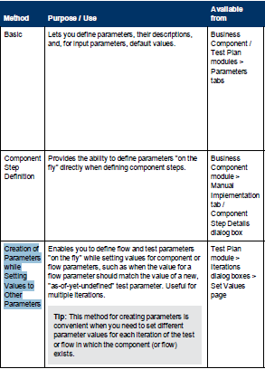

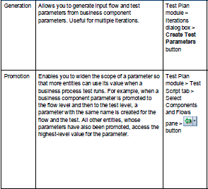

**Exercise**

* Create a business component
* Define the steps necessary to login into mercury tours
* Define input values for the component
* Set the password value as encrypted

**Steps**

1. Go to ALM
2. Log into The project available for the training
3. Go to the Business Components module
4. Under the Businees Components tree, create a folder and name it "BPT Training"
5. Go to Test Plan Module
6. Under the test plan Module, create a folder and name it: "Manual Tests"
7. Right click in the folder just created and select: "Create a New Component"
8. The Component will be called: "Login"
9. Under the manual implementation tab, create following steps for this component:
10. access to <http://96.226.128.114:11500/mtours/servlet/com.mercurytours.servlet.WelcomeServl> t
11. Type your username
12. Type your Password

4. Click Sign-in

1. Go to the Parameters Tab and then add two Parameters: Username(username) Password(password)
2. Make the password value as "encrypted" value